RISK ASSESSMENT for organised group led walks in a COVID-secure way
Please read the attached sheet “How to carry out a risk assessment”.
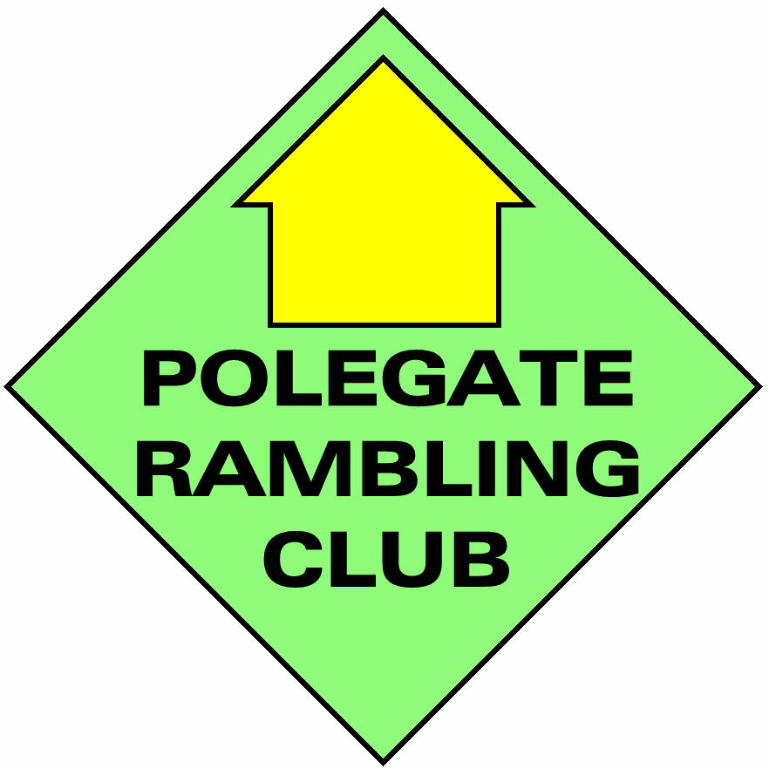

Use this risk assessment to help you understand the risks and any steps you need to take to stay safe before leading a group walk.
You do not need to tick every box. Send the completed form to Mick Kemp, Rambles Secretary, 20 Walnut Walk, Polegate, BN26 5AJ or email to mick.kemp@btopenworld.com to reach him by the Tuesday before the walk. N.B. NO FORM, NO WALK.

Walk Leader |  | Date of walk
Ramblers group | Polegate Rambling Club | Date of risk assessment
 |  | Date of recce

Possible hazards | Who might be harmed and how? | Ways to control the risk | Action taken?  (click on the box to tick)
Transmission of COVID-19 through close contact / meeting other people | Walkers, members of the public – risk of spreading COVID-19 | Plan the walk for a less busy time.
 |  | Avoid particularly busy or narrow routes where physical distancing is not possible.
 |  | Give clear information about booking to limit the group size.
 |  | Remind walkers beforehand about the guidelines, including on travel & transport.
 |  | Advise walkers at the start of the walk to maintain physical distancing from others – this is everyone’s responsibility. | ¨
 |  | Advise walkers what to do at any pinch points or road crossings to maintain physical distancing. | ¨
 |  | Carry a face covering in case of incidents. | ¨
 |  | Ensure you have a record of who attended the walk.
Transmission of COVID-19 through touching gates, stiles, fences or equipment | Walkers, members of the public – risk of spreading COVID-19 | Avoid touching gates and path furniture where possible.
 |  | Suggest walkers bring hand sanitiser and/or wear gloves.
 |  | Advise walkers not to share food, drink or equipment such as walking poles. | ¨
Possible hazards | Who might be harmed and how? | Ways to control the risk | Action taken?  (click on the box to tick)
Bad weather  (including extreme temperatures) | Walkers – risk of illness and injury, risk of the group being stranded | Check the weather forecast and postpone/cancel if necessary. Advise walkers to bring suitable clothing and items for the conditions. | ¨
 |  | Make a note of ‘escape routes’ on the recce. | ¨
Busy roads | Walkers – risk of vehicle collisions | Avoid routes along busy roads and/or check for suitable crossing places on the recce. | ¨
Steep, slippery or muddy sections. | Walkers – risk of trips/slips | Check for muddy/slippery sections on the recce and adapt the route if necessary. Advise walkers to bring suitable footwear for the conditions. | ¨
Livestock | Walkers – risk of injury  Risk of property damage if livestock escape | Cross fields with livestock calmly and quietly, keeping the group together. Be prepared to divert around livestock if necessary. | ¨
 |  | Follow the Countryside Code (England & Wales). Leave gates as you find them. | ¨
Cliffs or sheer drops | Walkers – risk of falls | Check paths are suitable for a group to use safely and make changes if necessary. | ¨
 |  | Follow any local warnings or signs, and advise walkers to keep away from the edge.
(Other hazards)

If you have any questions about Polegate Rambling Club group walks, please get in touch with the Rambles secretary: mick.kemp@btopenworld.com or 07484 104460
How to carry out a risk assessment

This template is a tool to help you plan and lead group walks safely. You must do a risk assessment for each walk.

- Use the template to assess whether your group walk is safe to go ahead.
- We've included suggestions for the ways to control the risks – you do not need to tick every box. The important thing is to identify the potential hazards and note the actions you will take to reduce the risk.
- It’s important to carry out a risk assessment before the walk takes place. You should start filling it out when planning your walk, and update it with any extra hazards that you notice on your recce.
- Think about the different types of hazards and risks. We’ve included some common examples, but think carefully about your own walk in case anything needs adding.
Examples of other risks might include:
  - Flooded paths, after heavy rain
  - Incoming tide for coastal routes
  - Unexploded ordnance (if walking on a right of way across a military site)

This isn’t an exhaustive list, so think carefully about any specific risks you may encounter on your walk.

- Next, consider the steps you can take to minimise the risk. Remember that this may sometimes mean changing your original plan. For example:

  - I will recce the route again to check whether the paths are flooded, and plan an alternative if necessary
  - I will check the local tide times and adjust the walk start time
  - I will read the local warning signs on my recce and advise walkers about the risks in my welcome briefing

- If you’re not sure what to do to reduce the risk, check with our Rambles Secretary at mick.kemp@btopenworld.com or by phone 07484 104460

Your volunteering & COVID-19

Due to COVID-19, there are extra steps we need to take to organise and lead group walks safely. Please visit the Ramblers website for the latest updates and guidance.

It’s essential for all volunteers to consider the following questions, when deciding whether to take part in Club activities:

Do you (or does someone else from your household) have COVID-19 symptoms? | If so, you should self-isolate for 7 days. If another person in your household has symptoms, you should self-isolate for 14 days.  You must not take part in Club activities during this time.  Symptoms include a high temperature, a new continuous cough and the loss, or a change to your sense of smell or taste. Find out more about COVID-19, and what you should do if you have symptoms on the NHS website
Are you ‘clinically vulnerable’? | If you (or someone you live with) are at higher risk of getting seriously ill from coronavirus, you should take extra care to minimise contact with others from outside your household.  Taking part in a Club activity may put you and those around you at higher risk. It may not be the right decision at this time.  Remember – everyone over 70, and those with certain underlying health conditions are considered to be ‘clinically vulnerable’
Do you want to volunteer, and do you feel safe and comfortable doing so? | Volunteering is a personal choice. There will never be any obligation or pressure to volunteer or take part if you don’t want to or are not able to at this time.

